**Computer Science**

**Mr K Govender(HOD), Mr M Aruna, Ms A Veiou, Mrs A Sulthana**

Welcome to the Computer Science department. Did you know that there are about 900 computers in our school? Almost every Department has its own computer room. There are 4 dedicated computer rooms and 4 teachers in the CS Department. All computers are running Windows, Office Web design, Scratch, python and many other software.

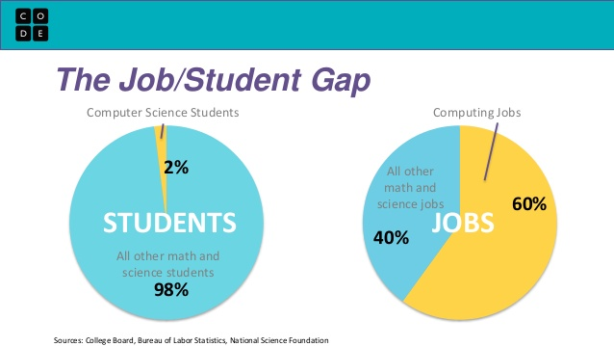

**Subject content**

**Y 7-9**— Theory of Computers e.g computer components, Binary numbers, Programming e.g Scratch, Flowol , Virtual micro:bit., Python

**Y 10-11-Optiion**—Computer Science OCR

- BTEC Digital Information Technology

**6th Form**—Computer Science OCR exam board &

BTEC IT - Edexcel exam board

Did you know that ALL games are written using code?

***Exam Results***

***Computer Science GCSE***

2019—92% 9-4

32% -8/25 students achieved 9-7 –A grade & above

2018—87% 9-4

37% -11/30 students achieved 9-7 –A grade & above

2017—86% A-C

